INTRODUCTION TO THE DRAFT

Chattyhive is a chat application and social network what it have an annonymous profile where we can interact with others users through topics of conversation in common and it create communities to share information in real time.

Maybe, it looks like a stale kind, however we are in front of a new concept for chats’ world what it want to bring us to the current day a large part of principles based in the chats during the first decade of this century: Annonymous users and group by chat rooms or discussion topics.

In 2012, Diego Ocampo, prime mover of this Project, starts to imagine how to update that chat called IRC what swept in internet 15 years ago and today it preserves some importance. As time goes on, It appeared the “big” socials networks as Hi5, MySpace or Facebook what they were changing the user experience when he used internet moving from a conversation about topics with an anonymous profile toward conversations focused in personal business with a real profile. Chats had a similar evolution from conversations in Messenger or ICQ until instant messanging embeded in the social networks.

Internet business is very changeable. In chattyhive, we think that all is not invented. There are still business opportunities and market niches where growth is posible. We are not the only who miss a revitalization about chat concept. A chat annonymous and thematic. Even today, there are thousands of active users or even, lot of people make a non orthodox use of instant messaging services such as Facebook or Reddit to créate chat rooms.

There are a big community comprised by geeks, universitary students and in overall, young people who wants to help thenselves, solving doubts and getting a communication in annonymous way according to affinities, meeting new people and take part in group with similar interests.

The Developt starts in September of 2013. At the begining with a slower pace, however, during the first semester of 2015, after several redefinitions both in the programming and in the design we have now the web-server almost finished, the application for Android in a 90% and we have defined the next steeps in the programation.

PROJECT PROMOTERS

The embryo in chattyhive was formed in the University of Vigo, in the telecomunications Faculty. Since that momento, several people have made its contribution. Nowadays, the team is formed by four people.

* [**Diego Ocampo Pérez**](https://es.linkedin.com/in/diegopau/es)

Telecommunications Engineer by University of Vigo (Spain). Ideologe and founder of this Project started in2013. He has taken over the thecnical coordination in the begining and he developt the part of the server. Nowadays he coordinates the part about the design and the usability.

* [**Guillermo Rocafort Lorenzo**](https://es.linkedin.com/in/guillermorocafort/en)

Master in Business Administration by University of Vigo (Spain). CEO in chattyhive since october of 2015. He is responsible for the organization, the business development and keep on contact with institutional customer and investors.

* [**Jonathan Rodríguez González**](https://es.linkedin.com/in/jonathan-rodríguez-gonzález-346517b0)

Telecommunications Engineer by University of Vigo (Spain). He started at chattyhive when this Project began his first steps, being a co-founder. He assumed the Android development and nowadays manage the thecnical area.

* [**Gabriela Hernández de Sequera**](https://ve.linkedin.com/in/maría-gabriela-hernández-de-sequera-15383153)

Degree in promotion and marketing by Technological University Rubino Blanco Fombona of Caracas (Venezuela). She started at chattyhive in October of 2015 and she is responsible of marketing and new markets research.

During this couple of years an a half, chattyhive had another people who collaborated in the past and they were a great help in some stages.

* Lorenzo García Cortiñas

He developed his end-of-degree project at chattyhive and he collaborated with us since September of 2013 to September of 2014. He helps us to program the backend.

* Xurso Legaspi Ramos

He developed his end-of-degree project and he collaborated with us since September of 2013 to June of 2014. He helps us to program the backend.

* Daniel Otero Prol

He developed his end-of-degree project with us since April of 2014 to January of 2015. He started the widget development.

* Guzmán Figueira Domínguez

He began with us in September of 2014 to February of 2015 working for the Android interface while he was developed his end-of-degree project.

* 1. STAFFING REQUIREMENTS

This part, it may be modified depending on financing and the company needs. In a first moment, Mr. Jonathan Rodríguez and Mr. Diego Ocampo would be out of chattyhive as workers. However, there is the possibility of joining at the company. Both of them would make mentoring task, some works as prototyping the app, area in which Mr. Ocampo is an expert, testing, documenting mishaps and coordinating the technical area as CTO (Mr. Rodríguez) and Mr. Ocampo as product manager. The main reason is that his part is almost finished and they believe that the best was getting another role without salary. There is the possibility of start at chattyhive as workers Mr. Rocafort and Mrs. Hernández as workers being general coordinator and marketing responsible respectively.

In terms of the staff requirements, at least it will be required two developers. An Android developer and a server developer will be required. It will be optional the hiring of a front-end developer responsible of giving shape to web-client if we want to have access from any web browser soon and it speeds the widget (It has the same technology). Also it would need an iOS developer to launch the application for an iPhone. Depending on financing and the needs, it is prioritized in the critical factors.

* 1. ASPECTOS LEGALES Y SOCIETARIOS

Chattyhive as firm is not yet legally stablished. It is registered the company name and logo by Mr. Ocampo. When the firm was stablished, he will yield to firm.

The percentage of the four partners as provided in a private agreement and it waiting for a new investor partner, is:

* Diego Ocampo: 47%
* Jonathan Rodríguez: 23%
* Guillermo Rocafort: 15%
* Gabriela Hernández: 15%

PRESENTATION OF THE PRODUCT

Chattyhive will be a free app what it offers a chat service and a social network focused to themes of conversation in where the users are interested.

Users explore theme lists suggested, can create a new topic and they are underwritten in the interesting topics for them to chat in an anonymous way, being update or make friends with people with similar interest.

One of the particular features of chattyhive is that each user will have a couple of profiles: A public profile identified with a pseudonym and an avatar and a private profile, just visible for these users who were added as friend previously with a friend request and subsequent acceptance. This private profile will be identified with the real name, the surname and a photograph.

The business model is supported by topics to talk about or rooms (hereinafter called “hives” and in anonym statistics on contributions made by the users in the public chats. Each hive will be categorized and it brings themselves a description and one or several tags. All this information will allow us to know the interests and needs of users as they use the service and it will be the basis in order to segment the advertising, promoted hives or to provide anonym statistics on trends about the use and the conversations.

Thereupon, we are going to give a whole revision about the features of chattyhive scheduled in the MVP. Further on, we will see a roadmap where it is all the stage in the near future.

1. REGISTER AND USER-LOGING

The user, when he opens the app for the first time, he will see either the welcome screen or the register screen.

For the register, we will be able to choose between it access entering our mail or through Facebook, Twitter or Google plus. Nowadays it is designed, however we are student the possibility of replacing twitter of Google Plus for Reddit whose growth it is very important and it possess important synergies with us.

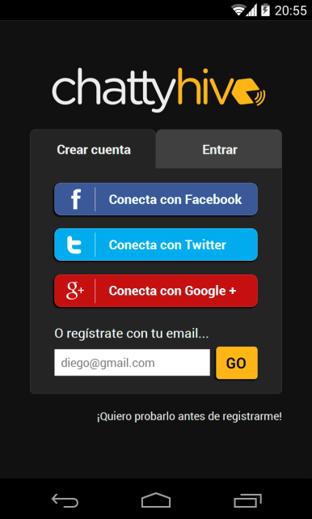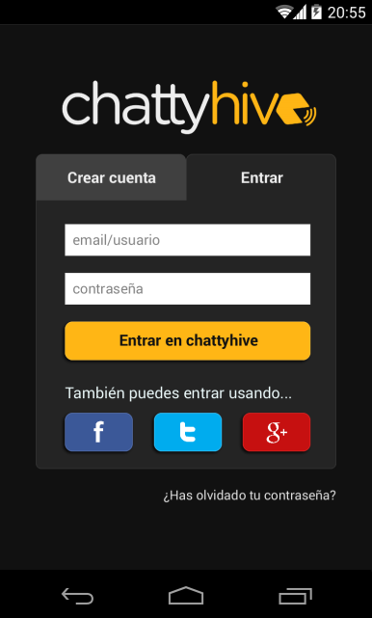

It is the first screen. It will appear before creating a new account.

Primera pantalla que nos encontramos antes de crear la cuenta.

Screen dedicated to enter at your session next times.

Pantalla dedicada para entrar en la sesión las sucesivas ocasiones.

Once authenticated the account, the new user will have three steps to do. In the case of connecting through social networks, part of the information is going to autofill from the data of the social networks. We have to fill private data as name, photograph, date of birthday, sex, place and language/s). In a second step, the user fills the public data profile: Name of user, avatar and the user will indicate if he wants any data included in the private profile. Finally, the user will enter their password.

Screen to enter the public data profile.

Pantalla para introducir los datos para el perfil público.

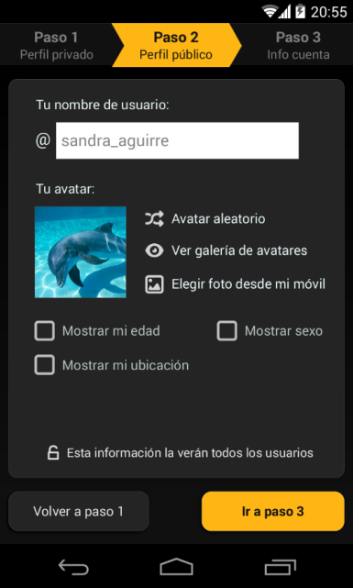

Set password

Establecer contraseña.

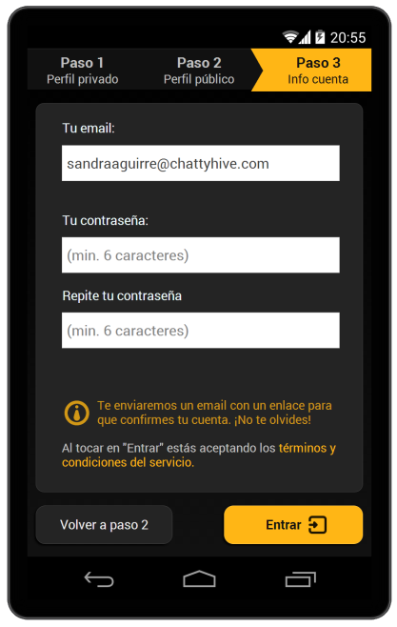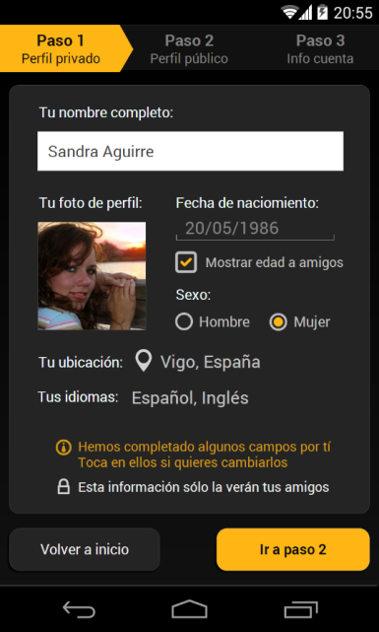

Screen to enter the private data profile.

Pantalla para introducir los datos del perfil privado.

3.1 QUICK START TUTORIAL: START TO USE CHATTYHIVE

Once the user has registered, he will access to quick start tutorial about chattyhive. It will be shown these basic features in order to get the best experience about chattyhive. The first functionality what we will learn it will be surfing by the “explora” section and how we be able to subscribe to a hive.

A hive is like a container of chats. It presents a kind of conversation where each user can subscribe it. It hive is inside of a category in accordance with the subject matter. It will have their own descriptions which it will be the main indicator besides the name to know if this hive interest to the user or no. There is the possibility of creating a new hive.

Each hive will have a public chat where the subscribed users will be able to chat in the same conversation and reed the things written by others. In addition, it will be able one or several private chats inside a same hive. This private chats can be between a couple of hivemates or a bunch of them. The main difference with a traditional chat room is the lack of being active in that “room” and it will be not necessary to access to public chat to start private conversations. In this hives, the users will be visible by theirs public profile.

3.2 FIRST SCREEN: TABS CHAT, HOW TO OPERATE?

Every time we want to access to chattyhive, once logged, the application brings us to the start screen or home. Look the capture 1 in the next illustration. This tab shows the most recent conversations, both in public chats, as private chats, between hivemates or friends where the user has written.

**Captura 01**

When we log, this timeline scren will be the first in being showed. This screen has all that links.

**Captura 01**

Cuando nos logueamos, esta pantalla de timeline, será la primera que nos aparezca. Desde esta pestaña podemos ir a los enlaces que se muestran.

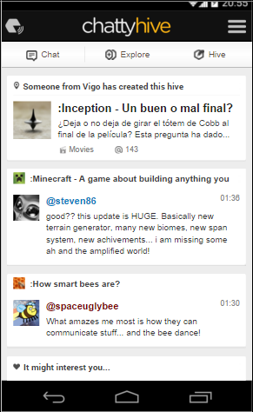

**Capture 04**

Menu items and notifications

**Captura 04**

Menú y notificaciones

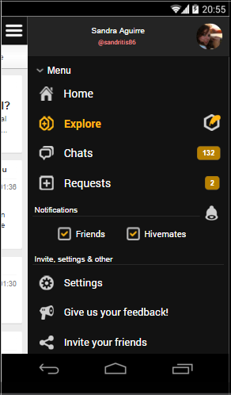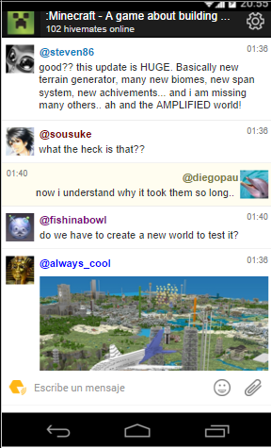

**Capture 06**

Public chat in a hive.

**Captura 06**

Chat público de un hive

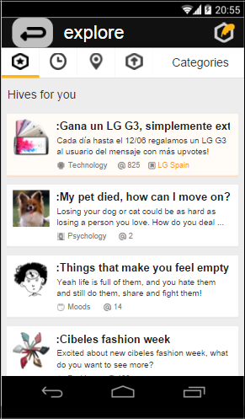

**Capture 02**

Explore tab.

**Captura 02**

Pestaña explore.

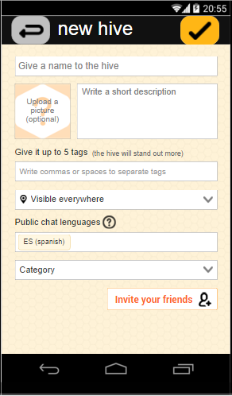

**Capture 03**

New hive.

**Captura 03**

Nuevo hive

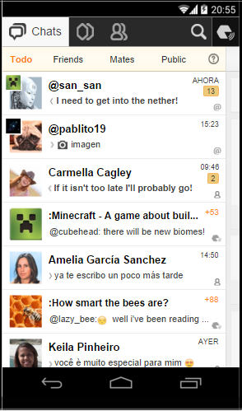

**Capture 05**

Chat tab.

**Captura 05**

Pestaña de chats.

From home screen we are able access to several parts in which it will be analysed all of them and these places where we can click.

3.4 EXPLORE TAB.

Here, the user will access to all the universe of hives created by other users, firms, organizations. The user can arrange the hives depending on different criteria, some of them related with the user profile.

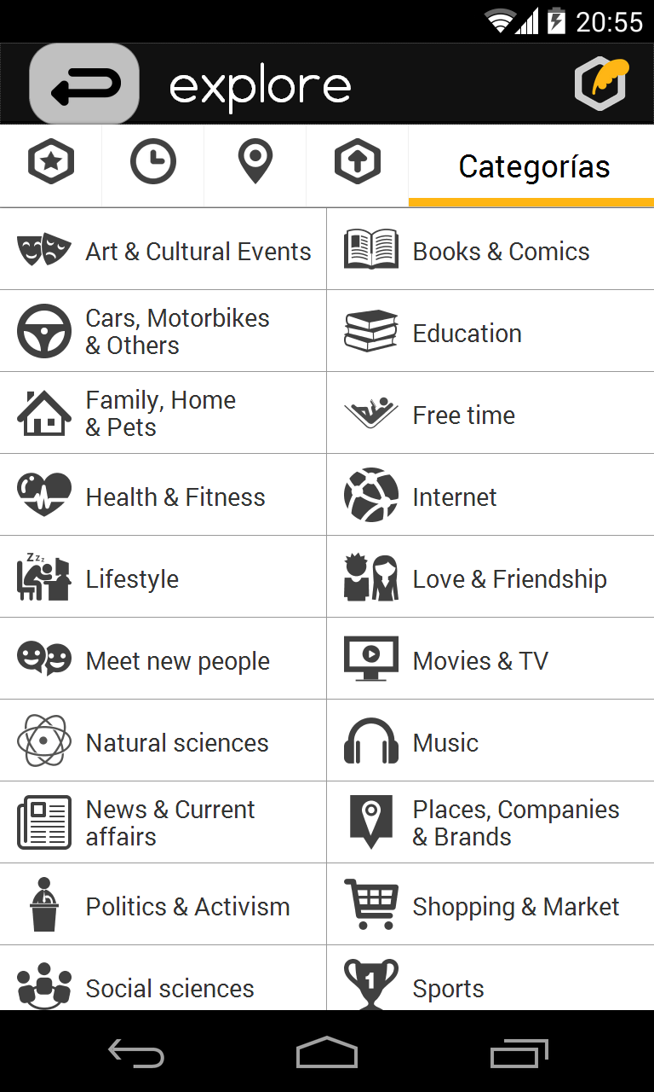

**Capture 07**

Clasification tab. If we do scroll down, we could see the the 24 categories by default.

**Captura 07**

Pestaña categorías. Si hacemos scroll down veremos las 24 categorías de las que se disponen por defecto.

**Capture 02**

H*ives for you* tab. It is a section inside explore tab with a selection of hives.

**Captura 02**

Pestaña *hives for you* que es una sección dentro de la pestaña explore.

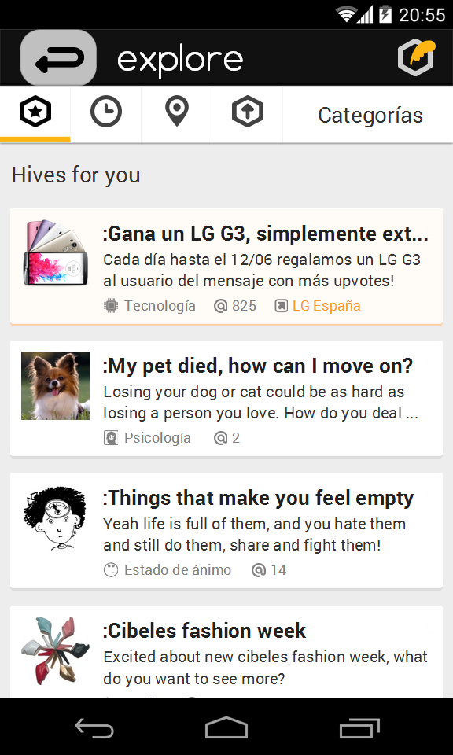

* Hives for you: It is an amount of hives recommended depending on our preferences according to the subscriptions done and how much the user has involved.
* Newly created hives.
* Hives close to you: Hives whose creator or subscribers live close to you.
* Top hives: Hives with the biggest amount of subscribers.
* Categories: Hives are arranged by themes and categories. Here, we can filter according to our interest.

**Hives close to you**

**Hives cerca de ti**



**Hives for you**

**Hives para ti**



**Newly created hives**

**Hives de reciente creación**



**Top hives**

**Top hives**



**New hive**

**Nuevo hive**



**Back**

**Atrás**

3.5 JOIN TO A HIVE

Once the user finds an interesting hive, he has to join to this hive. Making click above the hive, he could see more information and if the user is interested in it, he can join pressing the button “join hive”. Once subscribed, the button “join hive” changes to “public chat”. The new subscription appears highlighted in the top left corner as shown in the 9th capture.

**Capture 08**

Here, we can see the hive unfolded “Minecraft” and where you can join to this hive

**Captura 08**

Aquí podemos ver el hive desplegado “Minecraft” y donde unirse a ese hive

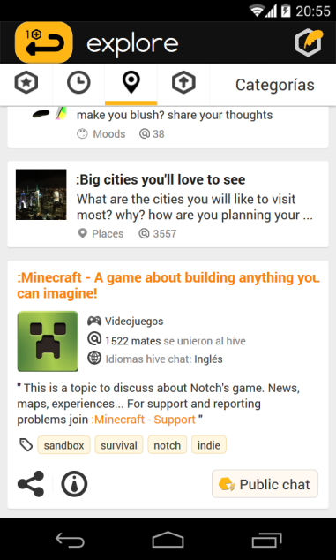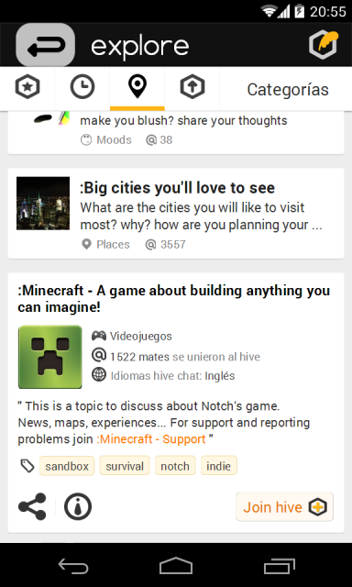

**Capture 09**

Screen just in the moment where the user has joined to “Minecraft” hive

**Captura 09**

Pantallazo en el momento en el que el usuario se ha unido al hive

Once subscribed, it is possible to access directly to public chat to take part in a conversation.

3.6 CREATE A NEW HIVE

If the user has not some hive interested, he can create a new hive to initiate a new topic of conversation. We can create the new hives from tab hive, from home screen, from the right panel of app or through the new hive button at explore screen.

To create a new hive is necessary:

* A name. It must be different from those already created. It will be the function of autocomplete to know if it exist a similar hive.
* A description
* One group within 24 to choose and it is subdivided in categories. It will be 100 categories to position more accurately the hive.
* A level of visibility. We can chose if we want the new hive was visible from just a country, a region or just one city.
* A photo. Optional. However, a hive without photograph will be decreased their visibility.
* A maximum of five tags. Optional. It helps to be more visible the hive, making more precise recommendations, and for the programmatic ads.
* Language. Language or languages may speak in the public chat.

Icons of the 24 categories

Iconos de las 24 categorías

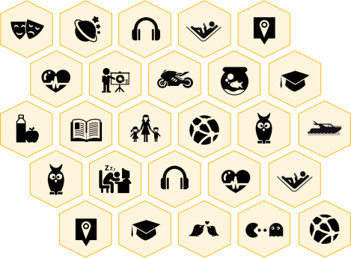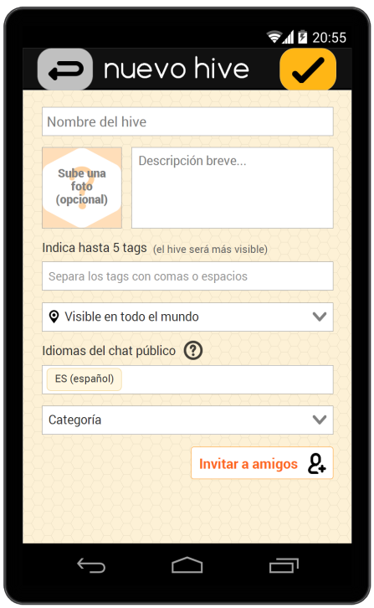

**Capture 03**

New hive

**Captura 03**

Nuevo hive

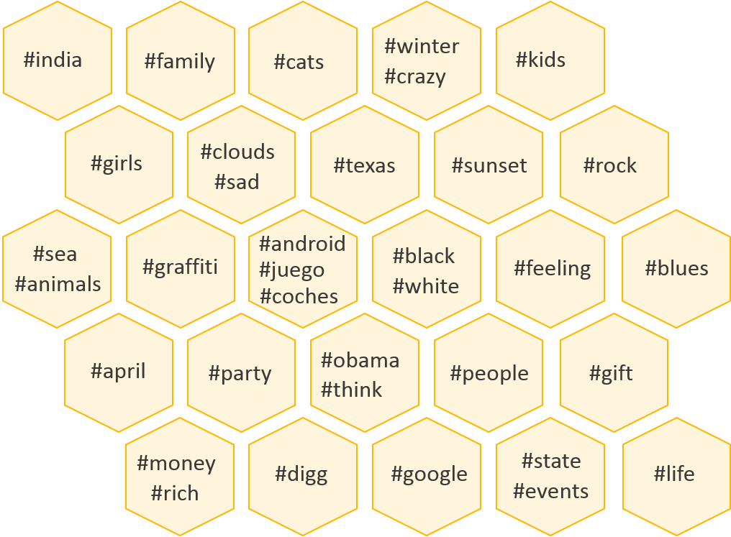

Tags inside each category. It can be a maximun of five tags by category

Al asignar al nuevo hive una categoría, podremos asignar hasta cinco tags

3.7 TAB OF HIVES, CHATS AND FRIENDS

In the left panel of the app, the user can manage everything related to the use of chattyhive: chats, hives subscribed and users added as friends.

The tab of chats is linked with the home screen or capture 01. When we press the in the logo at home screen, we access to the next screen of capture 05.

3.7.1 TAB OF CHATS

It is showed the most recent conversations (public and private chats) in what the user took part with another hivemate or a friend. The conversations are arranged from top to botton.

At the top of this tab, there is available a bar with filters in order to be able visualise everychats, only public chats, only private chats, chats with hivemates or just chats with friends.

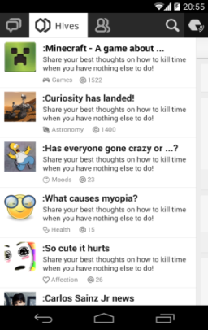

**Capture 10**

Hives subscibed.

**Captura 10**

Hives a los que está el usuario suscrito.

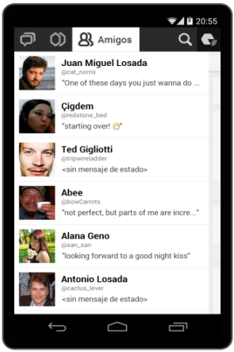

**Capture 11**

Users’ friends

**Captura 11**

Amigos del usuario



**Capture 1**

Home screen

**Captura 1**

Pantalla de chats o de inicio

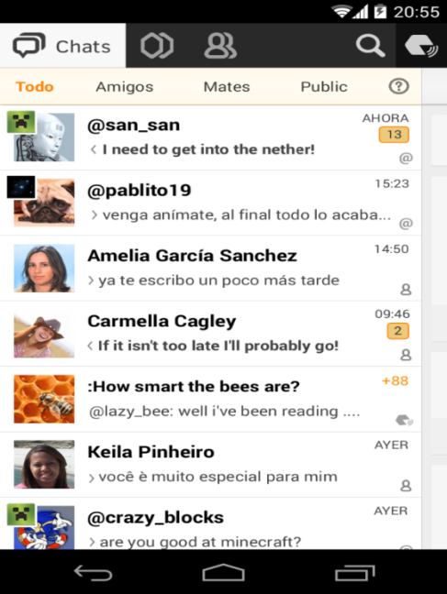

**Capture 05**

Chats tab.

**Captura 05**

Pestaña de chats.

**Chat filter bar**

**Barra de filtro de chats**

3.7.2 TAB OF HIVES

Every hive subscribed by the user is showed. In the top will appear these hives where the user has had the most recent activity.

Each hive can be expanded using two ways:

* Touching the image of the hive to access to the information of the hive (capture 12).
* Touching another part of the hive. Then, the hive will expand showing an access to public chat, a brief users list recommended and buttons to filter other users depending on place or recently online (capture 13).

In this point, inside a hive, we can cancel the subscription. This cancelation will eliminate everychats related with this hive.

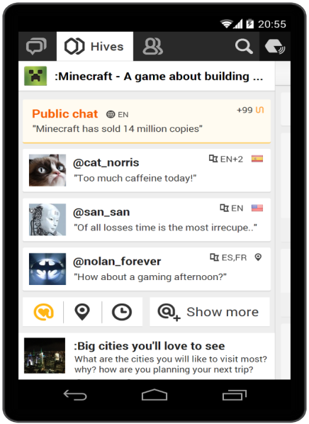

**Capture 13**

Public chat, hivemates and filters access of a hive.

**Captura 13**

Aquí accedemos al chat público, hivemates y filtros de usuarios del hive.

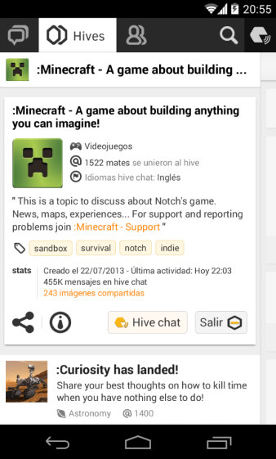

**Capture 12**

Hive expanded with its description.

**Captura 12**

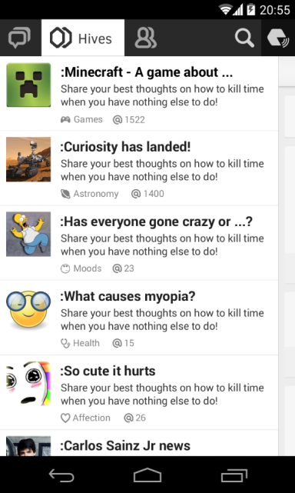

**Capture 10**

List of hives subscribed by the user. Depending on we press, we will access to public chat or to the hives description.

**Captura 10**

Lista de hives a los que está el usuario suscrito y según donde presionemos, vamos a una pantalla u otra del hive en cuestión.

3.7.3 FRIENDS TAB.

In this tab, the user will be all his friends inside chattyhive. His friends will be able see his private profile. Previously, it was send a friendship request and then this request was accepted.

The list is arranged by alphabetical order. From here, the user will be able start a private chat with any friend.

**Capture 11**

Our Friends at Chattyhive

**Captura 11**

Nuestros amigos en Chattyhive

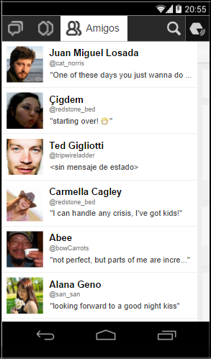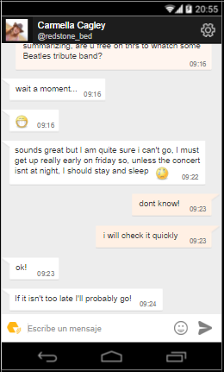

**Capture 14**

Private conversation with one of our Friends.

**Captura 14**

Conversación privada con uno de nuestros amigos.

3.8 MENU AND NOTIFICATIONS

Pressing at the upper right corner from home screen, we access to menu where some notifications as well as others features, adjusts, help and log off.

The fastest way to know how many comments we have in the chats subscribed, private messages as well as the friendship request.

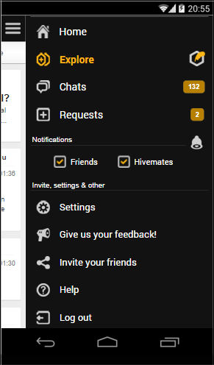

**Capture 01**

Menu screen

**Captura 01**

Menú de inicio



**Capture 02**

Menu explore

**Captura 02**

Menú explora

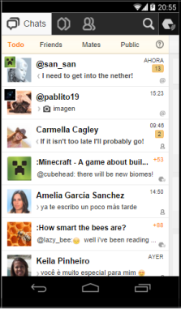

**Capture 05**

Menu chats

**Captura 05**

Menú chats

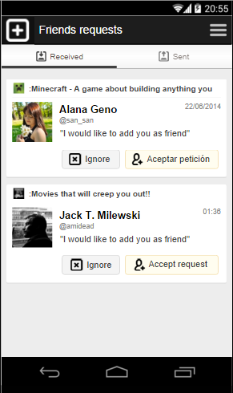

**Capture 15**

Frienship request

**Captura 15**

Petición de amistad

**SETTING**

**CONFIGURACIÓN**

**Capture 04**

**Captura 15**

Petición de amistad

3.9 CHATS.

Chats are the strength of chattyhive because under the same application are combined three kinds of chats depending on users’ needs and their privacy.

The three kinds of chats are going to share some functional features. Then, each kind has some peculiarities and a different context.

* Ability to share images and videos in youtube. The images will be stored at Amazon S3.
* Emoticons: Like others applications.
* Delivery report. It won’t book report.
* Sharing messages. We will able to share one or several messages in another chat in chattyhive or in another app.
* Chat context. It offers to the user a brief of the information shared recently in the chat.

3.9.1 PUBLIC CHAT.

Each hive has a public chat associated. In this chat, every hivemates can take part sharing messages or multimedia content simultaneously.

In order to take part in a chat is required to be subscribed previously.

Each message sent will have an avatar associated, a pseudonym, time of despatch and the content.

Touching the message, it is possible to mark a message from other users as “annoying”. If one user accumulates several messages marked as “annoying” by the rest of hivermates, he could be expulsed of the chat during awhile.

If we touch over an avatar, it will be move to user profile, open a private chat, block it or complain it. All complaints will be manually reviewed by chattyhive workers.

**Capture 16**

Public chat inside one hive. Making swipe we will go to captures 17 and 18.

**Captura 16**

Chat público de un hive. Haciendo swipe nos lleva a las capturas 17 y 18.

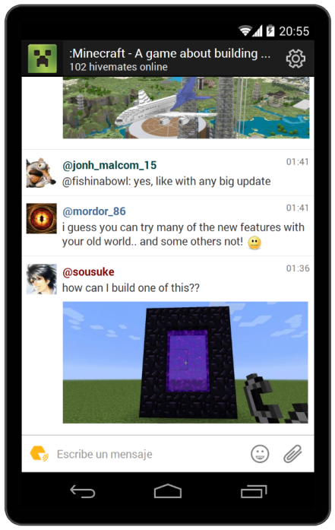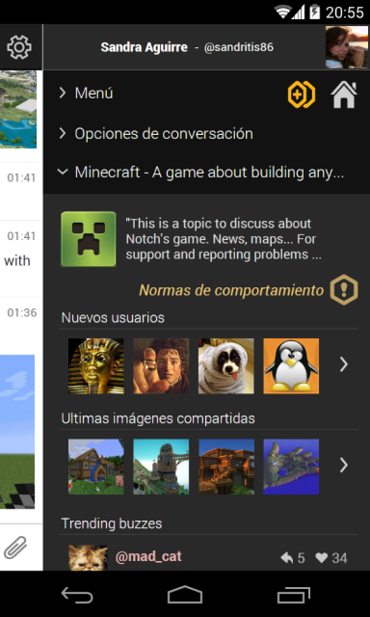

**Capture 17**

Hive context.

**Captura 17**

Contexto del hive.

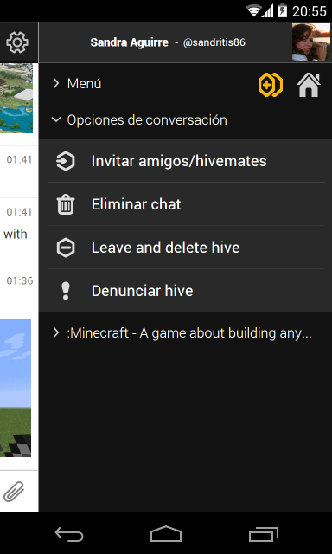

**Capture 18**

Conversation options in a chat.

**Captura 18**

Opciones de conversación de ese chat.

3.9.2 PRIVATE CHATS AMONG HIVEMATES

It is private chats between users in a hive. As well it is possible a private chat in a group inside a hive.

In the context of the private hive, there is an access to public profile of another user and we can see the latest pictures shared in the chat between.

3.9.3 PRIVATE CHATS AMONG FRIENDS

Are private chats between two users who, previously, they have been added/accepted as friends. This chat is no joined to any hive because of that, it can be the fact of the same users have two or more conversations, one for each private conversation inside each hive and another private conversation alien to any hive.

In a private chat, we can do swipe and then, we can access to the private profile of another user and the pictures shared between.

3.10 USER’S PROFILE

In chattyhive we have adopted a simple model to control de privacy so that the user may be the safety to know what information is showing in every moment. Separating the information between two independent profiles, simplifying the model and we get more transparency and confidence in the network as well it supplies additional control over our information to be showed. The user may show different versions about a same data depending on if this data is showed either in the private profile or the public profile. In example, the user can have a message in his private status just for his friends and a public status for the rest of users.

Therefore, every user has two profiles independent of each other:

* A **public profile,** visible for each user, identified with a pseudonym, an avatar and the public status as well sex, age and place just in case the user wants display it.
* A **private profile,** just visible for the users added as friends. In this profile, the users are identified with his name, surname, a picture, a private status as well sex, age and place just in case the user wants display it.

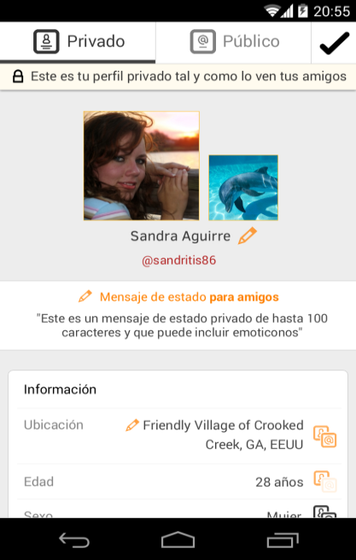

**Capture 20**

My private profile

**Captura 20**

Mi perfil privado

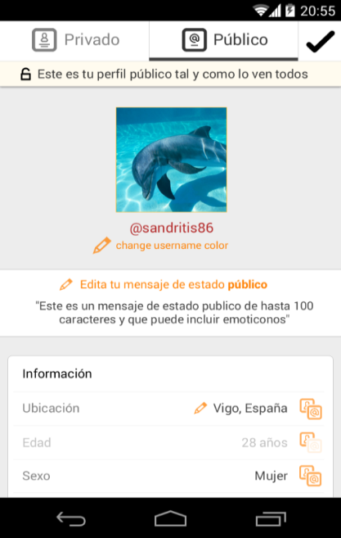

**Capture 19**

My public profile

**Captura 19**

Mi perfil público

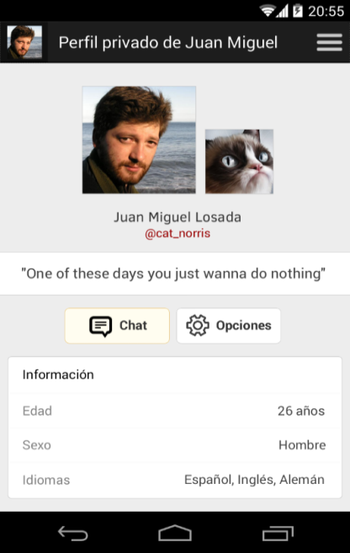

**Capture 22**

Private profile of another user

**Captura 22**

Perfil privado de otro usuario

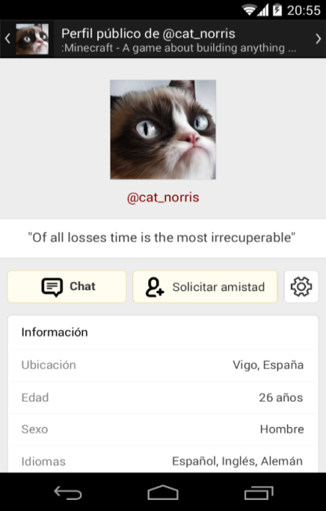

**Capture 21**

Public profile of another user

**Captura 21**

Perfil público de otro usuario

3.11 OTHER FEATURES

We have not to explain too much in this point, however, we will mention some screens what chattyhive contain.

* Friend request.
* Settings. Change email and password.
* Help menu
* Communities and widget. This functionality will be critical to obtain yields and it will be developed in a short term. Hereinafter, we will speak about.

3.12 PRIVACY AND SAFETY

The protection and safety about the user is a key factor and a differentiating factor. Protecting the user is critical for us to keep a relationship between the user and chattyhive avoiding intrusive features toward our users.

* Remove chat. The user may remove definitely any chat from his lists. In the case of private chats, the chat will be keep at our server if another user doesn’t delete the conversation. Public chats will be removed from our server when the own hive becomes eliminated. In the case of communities, the administrator of the community may remove a public chat in any time.
* Remove hive: One hive belongs nobody in particular. It just will be deleted if every user has cancelled the subscription to the hive. In the case of communities, the administrator may remove the community at any time.
* When you create a hive, the words will have a filter to avoid pornography and violence because we know our target market. Name and description will have a filter of coincidences to avoid any inappropriate content.
* Banish one user. When some user is blocked, he doesn’t send private message inside a hive.
* Report one user or hive. Users who break the behaviours rules of chattyhive, as that hive what break the contents rules may be reported. A report which must be justified. The human team will act these cases.
* Disable an account. The user will be invisible his profile to the rest of the user, however, he keeps his chats and subscriptions.
* Eliminate account. Every data of the profile will be eliminated although it is keep the subscriptions to hives keeping reserved the email and the pseudonym just in case the users wants to reclaim their account.

4 MARKET ANALYSIS

When we started to develop chattyhive in September 2013, we have studied and learned about the app market evolution and web business. And we have studied the evolution about social networks and app chats thoroughly.

It can be the trend to focus all social networks and all chats in two big groups. Inevitably, If we do a social network, public will compare us with Facebook or Twitter. In the case of instant messaging, we will be compared with Whatsapp or Telegram. However between couple of worlds, there is one Universe of market niches unexplored and in continuous exploration. At chattyhive, we have managed to find our niche and differentiate.

The most important is to get a position and know clearly our market due to it is very important to get an important growth at the beginning with a good app quality sacrificing the monetization to get better return in a long term.

4.1 SECTORIAL ANALYSIS.

Networks are changing every day. This is obviousness. Inside this obviousness we move finding our place to get a big growth.

We can speak about social networks without speak about Facebook. 1,400 millions of users make it the leader. However, even in Facebook there is changed in their use. His users have decreased an 8% during the last year in the world and in Europe a 6%. Its growth has stopped in 2013[1]. The frequency of use per week also has decreased in 2014 until 4 hours and 32 minutes, ten minutes less than in 2013[2]. However the incomes have increased during the last year. The fact that people continue using Facebook or other applications do not involve that they use more social networks apart from Facebook. In fact, the world average is to have 5,75 social networks per user[3].

Another opportunity to bear in mind is the increase about the use of internet as global tool. It has gone up from 1,75 to 2,24 uses about the three kinds of users (Productivity/education, leisure and communication). Among young people, the use gets to 2,75 uses[4]. Chattyhive can be positioned between the groups of productivity and communication due to it has elements of both.

Another very important point is to know how the user access to the network and how will it this kind of access. In chattyhive we may access to network with pc, tablet or mobile. Albeit, we pay attention to the changes, this way we are always prepared to optimize the application. In Spain, 88% of homes have at least one smartphone, 86,3% of homes has a pc and 54,4% a tablet[5]. It is very common the change among the devices when the user surfs the internet depending on time and place. Nowadays, the most important way access is through a smartphone. At least ten times per day the user access using apps. 31% of users open app from 16 to 30 times per day and 13% open apps more than 60 times in a day. This growth rate is increased 123% during the last year[6]. In Spain, the use of smartphone is an 81%, five points more than in UK. Within that 81%, there is 27,7 millions of users who they use apps every days. They have on average 30 app downloaded (24 in tablets) of which, 89% of the time, they spend using just 14apps.

About the use of smartphone in Spain, an 84% of users use Android where the age range more active it is young people between 25 to 34 years old. It is just our main target[7].

4.2 ANALYSIS ABOUT OUR COMPETITION: SOCIAL NETWORKS AND INSTANT MESSAGING.

In a first moment, you could think that chattyhive and Facebook are the same. It is true that both share some things however are different. Our main target is not the same although our users can be user of both social networks. At Facebook, you share your real identity to keep in touch with family and friends to share experiences, photos and videos. There is a lot of activity in the Facebook groups but the user is always with the real name and their experience is not as seamless as one chat. Google+ has not quite got off the ground. Then there are other applications as Badoo or Tinder whose goal is getting in touch and flirt with. There are social network focused on business area as Linkedin, Xing or Womenalia and social network just to share photos and videos as Youtube, Instagram, Vine, Periscope, Snapchat…

Likewise, while most of the applications based on chat are focused on a target consisted on singles which are looking for a pair or meeting new people. Chattyhive is focused on topics of discussion and we want engage a bigger range of people consisted on companies, intellectuals, communities from specific areas, news outlets, specialist people and in overall, every user which want to chat about those topics that really interest and also, getting in touch with that people which share the same interest than you.

When we talk about internet, we are talking about millions of potential users. A big part of those people are user of the main social networks and instant messaging however, there are a great amount of people which share his time surfing among several social networks or hardly ever use it. Users work with classical services as forums and the IRC or maybe, they explore new services which provide added value. Those kinds of users are who usually change the trends in internet, they are more active, more participative and more grateful when they see an app with quality which satisfice his expectations. However, they are more changeable and demanding with chattyhive, fact that we have to pay attention our user in every time. This will be our market target in a first time: graduates, geeks, computer scientist and restless people. One target focused in topics of conversation for people.

4.3 MAIN COMPETITORS OF CHATTYHIVE

Sometimes, you may tend to confuse within this market enemies with allies and to generalize the purpose and functionality of each of these services, usually by classifying them into two groups: social networks and instant messaging services. Albeit within those couple of groups, there are hundreds of services living together and growing at the same time. This it is possible due to there is different customers or users with needs and expectations completely different and, each application capable to cover it, has its space, its market. The few things that in example chattyhive have similarities with Facebook or Twitter it is just that both are in the technological area.

There are giants in this area however there is enough space for companies like chattyhive. Over time, new companies have emerged and some of them with important growth and one important number of users and a bright future.

We have deeply analysed more than fifty app around the world and we have selected the most direct competitors. However there are lots of elements where chattyhive is unique. The closest apps to chattyhive are:

* BANTER

This app is very similar to chattyhive although its design is simpler. It is an American app launched at the beginning of 2014. In that year, the application was very active until 2015 when his activity decay. In January it was his latest update but the service is still active.

The main alike with chattyhive is the essence of the old forums pooled in rooms, the equivalent to our hives. However, there are a lot of differences where chattyhive is winner:

Each “room” has a name but it neither is categorized nor tagged. Therefore, the search of one room is more complicated and each room has only one public chat. In our hives, apart from a public chat, we have like a container of users where they can interact among them privately or in a group inside a hive.

Each room has an administrator or a moderator. In chattyhive dispense with a moderator to release human capital and we think that, in this way, we give more power to the user deciding with his votes to get a self-moderation.

Banter lacks of a social network. It is just a chat. In chattyhive is key factor to rely on with two profiles.

Recently, Banter has launched “Chatfrog”. It is an application to chat to Reddit users although independent. Nowadays has no widely accepted but we pay attention in its evolution due to this is one of the synergies planned for us with our widget.

* VERSY

In their origin, this app is focused to instant messaging. However, with the great growth of Whatsapp, they begin differentiating to focus in groups of conversations. In this part is where we find similarities to chattyhive. It has channels ordered by categories. Apart from a public chat, each channel has its category and its own timeline made by the administrator. It is like a profile wall. However, there is no possibility to create chats or private groups within each category as it happens in chattyhive. On the other hand, we don’t see the possibility to create new groups. The groups are created previously by sponsors. His strong point is to be able to send message without WiFi among Versy users.

This app has a good market in Mexico where there is their 75% of users.

* COCO

This app has an important number of users in USA. It is fairly comprehensive. It has two strong points: Enhancing communication with phone calls and instant messages and it meets new people as well as offering to user a personal wall to upload photos and making comments. Another part and similar to chattyhive is the creation of public groups to chat. However, his focus is different because this is a complement of the app. Groups have a limit of users, it is not categorized and each user just be able create one group. If one user wants to create a second group, previously must delete the first. If the group is one week inactive, this group disappears.

Moreover, the administrator has the possibility to accept new members. This makes a contrast with our democratic vision where all users are the same and all of them are responsible to censure or to expulse one “troll” user.

* SPOTBROS

This Spanish app has his good days during 2013 when they are offering a good promotion to attract new customers based in offering one terabyte of storage. However, soon this offer had important limitations. Another feature related with chattyhive is the “spots”, groups of conversations like our hive. Albeit, there are differences between Spotbros and chattyhive such as in Spotbros only have one profile or each group has a moderator or administrator who control each spot.

After one year modifying his business model, it seems that Spotbros wants to boost their spots. They continue having their cloud but users only can access from a mobile or tablet although the files kept there have a deadline: 180 days. After this period, Spotbros delete these files.

In the past, Spotbros was very well reception but nowadays they has to overcome the situation. In Google Play has a low valuation: 3,7 and several critics.

* BEETALK

We are in front of one of the most successful app in the area with more than ten millions of active users. The Indonesian app established in 2013 grew very fast until August of 2014. Then, the growth started to moderate although it continues rising. The app has English language but hardly ever has presence in Europe. His main markets are Iran, Taiwan, Burma and Thailand. Basically, that is because the design is focused to Asian market.

Basically, Beetalk is an instant messaging app with a lot of features such as video calls, games, public profile, a global wall in which people can disclose content and filter publications depending on proximity, sending messages with self-destruction.

A new feature is called “clubs” which it is similar to our hives. Users grouped around a topic, a local or an event. Users have profiles with his real information. Clubs is not available in some parts of the world.

Although Beetalk is focused to different market than chattyhive, there are similar success features just in Asia. We think that this can be an incentive to run in Occident some like chattyhive.

4.4 DISTINGUISHING ELEMENTS OF CHATTYHIVE

* Focused toward an anonymous profile: Users show one nickname and one avatar to chat with unknown people.
* The user has a full control over his privacy. Each user has two profiles: A public profile displayed to the rest of users and another private profile just for friends.
* More emphasis on intellectual activities and sharing of knowledge.
* Good basis for implementing a business model.
* Private chats among hivemates are always “inside” the hive. This allow to know where, when and what are speaking people, getting information to apply to big data.
* We can elaborate statistics about usage trend.
* Ads can be showed to public target.
* Hives are well identified by categories, tags, description and language.
* Meeting people close from you with the same hobbies. Using the anonym profile, you can speak with people about a topic. It does not matter the physical appearance or the first impressions at the beginning, just mind the topic.
* The moderation of each hive is automatic. It is no necessary human capital. Cheaper and fair because the users are responsible to self-moderate the chat with votes.
* It is inspired in forums and IRC. Forums continue existing and it is the main solution to solve any doubt around one product, topic or videogame. Chattyhive wants to enrich the experience already existing in forums and to move it to a chat. We want make a complement more for interacting among users inside one community. Sometimes, some forums use a simple chats, however, chattyhive wants to improve the experience for the users from the web and from the mobile.
* It is allowed to register using others social networks. As well as, we can obtain data about others social networks to recommend possible interesting hives for our user.
* Modern and scalable interface prepared to new functionalities in the future.
* The “Explora” section. All hives are open and accessible to any user to choose its own criteria (Category, creation date,proximity...) Here, we can introduce elements in the business model related with the positioning of hives.
* Widget. When the widget will be developed in the short term, we are going to obtain important synergies with other webpages formed by communities. This webpages offer a service to their uses which it is a quality chat, perfectly integrated in the webpage and we will obtain a great amount of new users. Users can access from webpage or from app of chattyhive and this communities are visible from Explora tab.

7. MONETIZATION

In a first moment, it can seem complex the monetization due to the fact that this is not a product which generates money selling it. The incomes will come from other parts. Firstly, we have to highlight that the price of chattyhive must be free today and forever. Then, there is to explore new ways to get incomes and to know the economic potential of chattyhive. We are in an area where to grow and to have a critical mass, we have to sacrifice the current incomes.

The sector is already in a maturing period and in order to survive and succeed, we can’t put a banner like ten years ago to earn money from ads. We are in a moment where the user has much power of negotiation. He does not willing to pay for a basic service neither suffering an invasive advertising. If we do not make these precepts, the early adopter will be inflexible with us.

However, we will not dispense with advertising. In the future, advertising will be a strong part in our business but we have to wait to get a critical mass enjoying our app. Instagram in example, was established in 2010, two years after Facebook would purchase it for 760 Millions of euros. In 2014 Instagram starts to monetize and nobody doubt about the success with more than 400 Millions of users. It is better prioritize at the beginning the quality than prioritize monetize too soon in order to in a short time became a zombie app, without users.

Thereupon we are going to quote an overall idea about the potential of chattyhive. There are no fixed periods to implement because of depending on the feedback with users, we will are versatile to maximize the efficiency and it keeps optimal the user experience.

7.1 HIVES SPONSORED

In chattyhive we know the interest of the users because, according on he chats, we can know the topics with more traffic, how many topics the users take part, how much time the user spend and, due to there are private profiles, the user is no exposed directly to the rest of society an can feel free when he chats. It may promote a hive existing or create a new hive according to the interest of the users.

At the same time we have a critical mass, we will generators about information. This anonym information has economical value and it may be traded. Companies would be interested in interacting with his customers or potential customers.

These promoted hives might interest to user to introduce a local event or to meet people who shared an interest in common. Famous people also can use it to promote a work or an event to increase his notoriety.

Companies may obtain great advantages due to it is another instrument to promote his brand. These hives may be temporary and be separated of the main hive of the company. If the users chat over a brand, could be one of the best sources of information for the company.

7.2 COMMUNITIES

The communities open one universe about the information management by a company or organization. It is the best option for webmaster and community manager if they want to keep their official hives around a product, company or initiative. The community allow manage several public chats. On the contrary than in hives, here it is possible to moderate and administrate a chat. The communities are not free. His price will depends on the features such as the number of public chats within one community, or the number of communities managed by each administrator.

An example over the usefulness of a community is a hotel. One hotel with a community and using one hive, the administrator give access to customers and, the customer among then can chat, the hotel can do promotions an tourist advices…

Thank the widget of the community, chattyhive can speak with others webpages and forums and it provide an element of communication plenty of quality. The webpages which host our widget could get synergies and improve interactions with their users.

In webs as streaming services, sale of products, videogames, ONGs… it would be feasible to install our widget to improve the experience customer/user.

7.3 IN APP PURCHASES

This element can be implemented in the first days. It is no necessary a big number of users. Using micro-payments, chattyhive can sell a set of features and functionalities to improve the satisfaction of the user, such as the sale of stickers, the sale of animated emoticons, personalize your avatar or the backgrounds of chat shared (One user can see the background image of the other user and vice versa). These are only some examples but we will in continuous movement to increase new functionalities.

7.4 PREMIUM SERVICES

In a long time, through a monthly subscription, it would be to access a pack of features to improve the users’ experience.

Some advantages are the possibility to inactive the advertising, filters more advanced based on the reputation in some tags, very useful to find experts in some topics. Exclusive hive with users limited, hive with restricted access, free access to in app purchases (see previous point)…

7.5 SALE OF STATISTICAL DATABASES ABOUT CONVERSATIONS

When we have an important critical mass, we will have a big amount of data in order to be used generating information. It is useful information to companies about trends in conversation. We know that others companies offer data over trends but, our point of view it would be different due to our information is about conversations in chat mode. The big amount generated by one tag or several tags, how many private chats are opening speaking about one topic, trending changes…

7.6 TARGETED ADVERTISING

We will provide enough capacity to introduce this kind of advertising although it will be less intrusive not to punish us abandoning the app.

Based on a RTB system (real time bidding) which it enables to reach in each advertisement just to the users possibly interested through a bid system. Depending on how much money the advertisers are willing to pay per each click, per thousand impressions or per each interaction between users and advertisers. This way to work is wide used and successful however it has one problem: The user can see as intrusion in the use. We have to implement one strategy thinking in the customer care.

In a first moment, it would use doublecklick for publishers. Implementing it is easy and every ad would be provided by AdSense of Google. This it helps us to define the target. In a future, we can develop our own ads interface for the companies which want create advertising campaigns.

Another option for the future may be to incorporate contextual advertising in real time for conversations. It would be ads visible for every user which are interacting in this moment simultaneously. With this, we will foster the interactivity between the ad and the users being able to generate a new discussion about the product publicised.

8. ESTIMATION OF REVENUES AND EXPENDITURES

One of the main peculiarities about chattyhive as business focused in internet is the lack of fixed assets. Its best asset will be the staff.

We have done a model of revenues and expenditures to three years in a future with all possible movements in the company. We have a couple of outlooks: Three years and five years (using for the fourth and fifth the data of the third year).

8.1 INVESTMET ALREADY MADE AT CHATTYHIVE

When we began the programming in 2013, we have invested lot of hours of programming. Eight people collaborate or have collaborated. Until January of 2016, we have invested a total of 12.000 hours some of which belong the 69.4 % to Diego Ocampo and Jonathan Rodríguez. These hours, we have valued in 15 euros per hour. This is 180.000 euros investment in human capital approximately. We have to add 1,946 euros spend in different concepts. The result is 820 programming code contributions and 15,518 lines of code added. About Android, we have 487 programming code contributions and 88,400 lines of code added.

8.2 FORECAST OF EXPENDITURES IN THE THREE FIRST YEARS

Next, each expense will be described in detail. It is an estimate. The expense may change depending on initial investment and the evolution in respect of the number of users. Later, we will show three possible scenarios.

8.2.1 OFFICE EXPENSES

We apply an inflation rate of 2 % (In March 2016, the inflation in EU is -0.05%[8]). In year one, the concept about rent is higher due to the deposit.

|  |  |  |  |  |
| --- | --- | --- | --- | --- |
| **OFFICE** |  | TOTAL YEAR 1 | TOTAL YEAR 02 | TOTAL YEAR 03 |
| Rent |  | 5.600 € | 4.920 € | 5.018 € |
| Supplies (Water, internet, elect…) |  | 2.400 € | 2.640 € | 2.693 € |
| Improvements |  | 500 € | 500 € | 500 € |
|  |  |  |  |  |

8.2.3 COST OF STAFF

We have started out from hiring four computer scientists with an annual gross cost of 21.000 euros and two coordinators that, during the first years, they would be in part-time work. In the third year, a new developer would be hired.

|  |  |  |  |  |
| --- | --- | --- | --- | --- |
| **EMPLEADOS** |  | TOTAL YEAR 1 | TOTAL YEAR 2 | TOTAL YEAR 3 |
| |  | | --- | | Android developer | |  | 21.000 € | 21.420 € | 21.848 € |
| Social welfare |  | 7.260 € | 7.404 € | 7.560 € |
| Server developer |  | 21.000 € | 21.420 € | 21.848 € |
| Social welfare |  | 7.260 € | 7.404 € | 7.560 € |
| Front-end developer |  | 21.000 € | 21.420 € | 21.848 € |
| Social welfare |  | 7.260 € | 7.404 € | 7.560 € |
| iOS developer |  | 21.000 € | 21.420 € | 21.848 € |
| Social welfare |  | 7.260 € | 7.404 € | 7.560 € |
| General coordinator |  | 7.200 € | 7.344 € | 21.848 € |
| Social welfare |  | 2.491 € | 2.541 € | 7.560 € |
| Marketing coordinator |  | 7.200 € | 7.344 € | 21.848 € |
| Social welfare |  | 2.491 € | 2.541 € | 7.560 € |
| Developer 5 |  | 0 € | 0 € | 21.848 € |
| Social welfare |  | 0 € | 0 € | 7.560 € |
|  |  |  |  |  |

These numbers are starting points. Depending on other less optimistic scenarios or the initial investment, it might vary the number of employees hired initially, not hiring the fifth developer or during the third year following the coordinators in a part-time work.

8.2.4 MARKETING

Marketing will be mainly online. Its expenses are going to grow over the years. We want do strong strategies free in order to boost the app. However, to improve the visibility, we have to invest money in marketing.

The amount can be modified depending on the scenery and the growth rate. However, we want to do an approximation the most reliable possible.

|  |  |  |  |  |
| --- | --- | --- | --- | --- |
| **MARKETING** |  | 3.100 € | 17.600 € | 60.000 € |

8.2.5 TECHNOLOGICAL VARIABLE COSTS

It is difficult to calculate the technological cost due to the fact that it depends on the number of users. A higher number of user, higher cost.

The technologies used will be: Pusher, Heroku, Sentgrid, Postgres, Amazon S3 Cloudfront and Bitbucket. In the table below, we added every cost monthly in euros and depending on the number of users. Some cost are in dollar originally but we convert in euros (change rate 1$/0,916€). These prices are not depending on us, it can be modified by suppliers. However, if we see the prices movements, it would be possible to reach a decrease or to change of suppliers looking for the best rate between quality and cost.

|  |  |  |  |  |  |  |  |  |
| --- | --- | --- | --- | --- | --- | --- | --- | --- |
| Active users per each month |  | 5.000 | 50.000 | 100.000 | 500.000 | 1.000.000 | 5.000.000 | 10.000.000 |
| Simultaneous active users (5%) |  | 250 | 2.500 | 5.000 | 25.000 | 50.000 | 250.000 | 500.000 |
| Technological costs |  | 5.119 € | 50.387 € | 100.832 € | 505.139 € | 1.011.213 € | 5.030.875 € | 10.061.222 € |
|  |  |  |  |  |  |  |  |  |

8.3 INCOME FORECAST

The incomes will depend on the number of users. We are going to foresee to obtain three cents per user each month. (36 cents per year/user minus taxes).

If we make a comparison with others social networks, Facebook has increased from 3 dollars in 2010 to 11.96 dollars[9]. Twitter has increased its incomes from 1.06 dollars in 2011 with 100 Millions of users to 4.38 dollars with 320 Millions of users in 2014[10]. Google plays in another league, earning more than 40 dollars per user according to a study of Kleiner Perkins Caufield Byers[11].

8.4 SCENARIES

Next, we are going to show three different sceneries. [Draw from the premise](http://www.linguee.es/ingles-espanol/traduccion/draw+from+the+premise.html) of what is indicated above and making slight modifications in the conservative scenario.

We have made three estimations based on three growth patterns of users during three years. In the fourth and fifth year we use the same data than the third year. We have studied the growth of others social networks in its first years[12][13].

8.4.1 BASE SCENARIO

Basically, in this scenery we take the data already showed with six worked at the beginning (two in part-time) and a fifth developer at the beginning of the third year. The app will be launched to the market in the eighth month and eighteen month after, we will start to obtain money.

|  |  |  |  |  |  |
| --- | --- | --- | --- | --- | --- |
| BASE SCENARIO | **YEAR 1** | **YEAR 2** | **YEAR 3** | **YEAR 4** | **YEAR 5** |
| Average of users | 477 | 428.333 | 13.098.005 | 13.098.005 | 13.098.005 |
| INCOMES | **- €** | **113.476 €** | **3.725.072 €** | **3.725.072 €** | **3.725.072 €** |
| EXPENSES | **150.155 €** | **189.940 €** | **769.469 €** | **769.469 €** | **769.469 €** |
| **OUTCOMES** | **-150.155 €** | **-76.464 €** | **2.955.604 €** | **2.955.604 €** | **2.955.604 €** |

|  |  |  |
| --- | --- | --- |
| ir: 2% | THREE YEARS | FIVE YEARS |
| NPV | 2.564.426 € | 7.971.929 € |
| IRP | 319% | 372% |

8.4.2 SCENARIO CONSERVATIVE

It is the scenario more complex. Its initial investment will be less than others scenarios and the launch of the app will be during the eleven month. About staff, just two would be hired during the first two years and three staff during the third year. All of this means an important saves in computers and salaries but we miss time launching the app for Android and Computer. Marketing expenditures would be 16,800 euros less than others scenarios.

|  |  |  |  |  |  |
| --- | --- | --- | --- | --- | --- |
| **CONSERVATIVE SCENARIO** | **YEAR 1** | **YEAR 2** | **YEAR 3** | **YEAR 4** | **YEAR 5** |
| Average of users | 42 | 9.656 | 1.252.827 | 1.252.827 | 1.252.827 |
| INCOMES | **- €** | **2.525 €** | **356.304 €** | **356.304 €** | **356.304 €** |
| EXPENSES | **90.137 €** | **102.555 €** | **274.585 €** | **274.585 €** | **274.585 €** |
| **OUTCOMES** | **-90.137 €** | **-100.030 €** | **81.719 €** | **81.719 €** | **81.719 €** |

|  |  |  |
| --- | --- | --- |
| ir: 2% | THREE YEARS | FIVE YEARS |
| NPV | -107.510 € | 42.002 € |
| IRP | -45% | 11% |

8.4.3 OPTIMISTIC SCENARIO.

Taking into account the scope of internet and can reach to all parts in the planet easily, we must not exclude a scenario with a high growth. The values are the same than in the base scenario: six worked at the beginning (two in part-time) and a fifth developer at the beginning of the third year. It would increase the technological variable cost due to the increase of users.

|  |  |  |  |  |  |
| --- | --- | --- | --- | --- | --- |
| **OPTIMISTIC SCENARIO** | **YEAR 1** | **YEAR 2** | **YEAR 3** | **YEAR 4** | **YEAR 5** |
| Average of users | 1310 | 3.807.633 | 55.252.627 | 55.252.627 | 55.252.627 |
| INCOMES | **- €** | **1.014.551 €** | **15.716.691 €** | **15.716.691 €** | **15.716.691 €** |
| EXPENSES | **150.155 €** | **362.952 €** | **998.518 €** | **998.518 €** | **998.518 €** |
| **OUTCOMES** | **-150.155 €** | **651.599 €** | **14.718.173 €** | **14.718.173 €** | **14.718.173 €** |

|  |  |  |
| --- | --- | --- |
| ir: 2% | THREE YEARS | FIVE YEARS |
| NPV | 14.348.350 € | 41.276.369 € |
| IRP | 1131% | 1171% |

8.5 FINANCIAL NEEDS

Chattyhive is a start-up which requires a big investment in the technological part. For its first years, the investment was mainly work hours in order to develop the technological part in Android and server. These needs will be kept when the app was launched: Regular updates, develop app for other operative systems and devices and the maintenance in order to the app was stable and secure. These tasks require several developers working at the app.

There is a variable part which depends on the goals and the investment during the first year. Depending on the investment the launch for iOS or the interface web may be soon or later as well as the promotion during the launch.

Over the years, the effort in marketing in addition to the technological cost (hosting and cloud services) will be stronger overcome the staff cost.

Depending on the amount invested by the external investor, it is going to change the investment criteria. From 90,000 euros during the first year, it would be possible to prepare the app to be launched and looking for a second investor during the second year. The optimal amount would be 200,000 euros to get a good basis of growth during the next couple of years and starting to obtain incomes from the third year. Nevertheless, we are very flexible to adapt to environment and we have the possibility to work with several rounds of equity finance.

9. VOCABULARY

**App Android:** In a first moment, it will be our only customer to access to chattyhive. It will be suitable with Android 2.3.3 and next versions. We can put the device horizontal and vertical except for during the register screen.

**Categories:** Each hive or each community has assigned one category to establish a reference and easing the searches by the users.

**Public Chat:** It is a conversation inside a chat where all users subscribed in this hive may take part.

**Private chat with other users inside a hive:** It is a conversation one by or in a private group with users subscribed at the same hive. In this kind of chats, the users always show their public profiles.

**Private chat with friends:** It is a conversation one by or in a private group with friends out of any hive. Previously, these users have established a friend relationship in chattyhive. In this kind of chat, the user shows his private chat.

**Communities:** It is like an advance hive. The main difference it is that in the communities there is one administrator, one owner and one moderator. It is focused to organizations and companies. It is expected that communities became one of our income sources. Depending on features hired, in a same community may be more or less public chats in addition to the widget.

**Context:** Screen which provides to the user all the information about one chat, last images shared or new users.

**Reports:** All users who disturb to the rest of user or do not respect the rules of chattyhive, may be reported. These reports have several blank fields to be fulfilled: User reported, user who report, hive where the problem happens, reason of the report and the description of the report.

**Hive:** It represents a topic of conversation or one community of users. Users have to subscribe to one hive to start private chats or taking part in the public chat. Every user can create new hive. Hives have neither moderator nor administrator, the users of each hive are responsible to report that user whose behaviour is not adequate in the public chat.

**Hivemate:** Every user subscribed in a same hive. They can chat by public chat or by private chat inside the hive.

**Language:** Users may specify one or more language allowed to use in each hive. This it is very useful to find coincidences in users recommended. If some users chat in another language, they may be considered as disturbing.

**Interface web of community management:** It is a web-client from any user may log in the service to create or modify the parameters which he has created or manage. From this web interface, you can create or eliminate communities, modify its information, reassign new administrators (just for the owner of the community) or moderators (it may do the owner or the administrator) and modify the information about public chats of the communities.

Later, this web interface will be which the community managers will use. They pay depending on the features chosen. In this interface, they will manage the subscriptions and pay methods.

**Messages:** It is the basic elements which shares the chats. Each message may be text, one image, one video, text + image or text + video. Each message has assigned one issuer, date and time.

**Friendship screen and friend request:** The user may do friendship request to the rest of users in a hive or accepting the request received. Adding one user as friend implies the access about the private profile and belonging to the friend list where you can start a new conversation out of a hive.

**Menu screen:** It is the screen which appears when the user makes start in the application. It will be showed cards whit the last public chats where you are subscribed.

**Explora screen:** It is the screen where the user surfs by list about every hive available. The user can touch in anyhive to see more information about, subscribing it or begin to chat inside this hive with other users.

**User profile:** Every user will have a couple of profiles: A public profile and a private profile.

**Private profile:** It is a profile where is showed the real name, surname, picture and age to the rest of friends in chattyhive.

**Public profile:** Profile where the user uses in every chat public and private inside a hive. It is anonym and just is showed one avatar and one pseudonym.

**“Chat”, “hives” and “friends” tab:** It will be showed at the left panel of the screen. It represents the information accumulated about the use: chats opened, hives subscribed and friends.

**Server:** It receive request from the client (nowadays from the app android and the web interface about the communities management). It process the request and send an appropriate response. As well, it sends the chat messages and notifications in real time to the users. It is developed using the framework Django.

**Tags:** Within each category, we can find lot of topics. If we want to refine the searching, it is very useful. It is allowed until five tags or key words linked to a hive or community.

**Location:** Users introduce their localization in the register (country, region and town). The localization helps to find coincidences about users recommended to start a private chat within a hive.

**Users:** It is the most important in the application. They can start session using their pseudonym or their e-mail. Each user will have two profiles: One public and another private.

**Visibility:** One hive may be visible for everybody or just for one location (i.e. just one country, or just one region or just one town); in this way, just the users who share the same location can see this hive in *explora* tag. If one user far away of hive location wants to joint it, he will just subscribe with an invitation.

**Widget:** Application for chattyhive available to communities. It is to be embedded in other webpages in order to dispose of a public chat supplied by us. This is a key part about our business.

1. http://marketing4ecommerce.net/facebook-el-nmero-usuarios-no-crece-pero-s-su-engagement/
2. VI estudio de redes sociales de IAB Spain.
3. http://marketing4ecommerce.net/cinco-redes-sociales-por-persona-la-media-mundial-del-social-media/
4. Fundación Telefónica: La sociedad de la información en España 2014; P.58
5. Fundación Telefónica: La sociedad de la información en España 2014; P.65.
6. Fundación Telefónica: La sociedad de la información en España 2014; P.72.
7. http://www.theappdate.es/blog/informe-sobre-las-apps-en-espana-2015-la-era-appcommerce/#
8. http://es.global-rates.com/estadisticas-economicas/inflacion/indice-de-precios-al-consumo/ipca/eurozona.aspx
9. http://www.eleconomista.es/tecnologia/noticias/7324758/02/16/La-publicidad-sostiene-a-Facebook-pero-cuanto-ingresa-por-cada-usuario.html
10. http://www.nasdaq.com/symbol/twtr/financials?query=income-statement
11. http://blogs.infobae.com/tecno-y-media/2015/04/27/tiempo-que-tardaron-en-alcanzar-los-100-millones-de-usuarios-diferentes-servicios/
12. http://blogs.infobae.com/tecno-y-media/2015/04/27/tiempo-que-tardaron-en-alcanzar-los-100-millones-de-usuarios-diferentes-servicios/
13. http://www.webempresa20.com/blog/las-30-redes-sociales-mas-utilizadas.html